CECS 328 Study Guide Part 3 Materials: Binary Search Trees (In Order Tree Walk, Minimum, Maximum, Tree Successor, Inserting Nodes, Deleting Nodes, Pre Order Tree Walk, Post Order Tree Walk), Dynamic Programming (Rod Cutting Problem) and Greedy Algorithms (Activity Selection, 0 – 1 Knapsack, Fractional – Knapsack). Final Exam is Cumulative (Midterm 1 and Midterm 2 Stuff to appear)!
Updated as 5/9/20 3 AM
Chapter 12 – Binary Search Trees
Section 12.2 Querying a binary search tree
Tree Minimum
*Finding the minimum value of a binary search tree: Traverse the left edge all the way down to the bottom. (DO NOT USE RIGHT EDGE to find minimum value). Only use the LEFT EDGE!
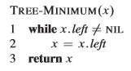
Tree Maximum
*Finding the maximum value of a binary search tree: Traverse the right edge all the way down to the bottom. (DO NOT USE LEFT EDGE to find the maximum value). Only use the RIGHT EDGE!
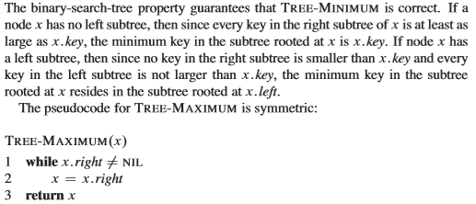
*For tree minimum and tree maximum, keep going down the left or right (while loop) and STOP WHEN x.right == NIL or x.left == NIL, then return x.

Tree Successor
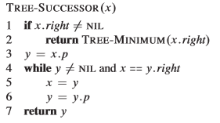

*If there is a right child or a right subtree, then output the minimum of the right subtree.
Otherwise (if x.right = NIL), you traverse up via the parent.
*.p means the parent of the node.
It is assumed that the pointer of the node is the same as the node itself (e.g.: Node 6 is the node that has the value of 6).
The minimum/maximum of a single node tree is the node itself.
*Parameters: x represents the node that you are looking for the successor for.
Tree Insert
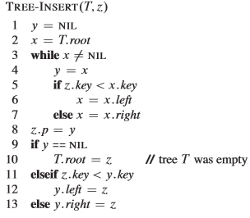
*Parameters: T represents the binary search tree, and z represents the new node with a value that you want to insert.
Lines 3 to Lines 7 determine where the node that you want to insert goes.
Lines 8 to line 13 actually places the node and inserts the node.
*Concept: Basically, you are looking for the right location within the tree to insert a node.
*High – Level: What is happening is it’s going to be doing a check, it’s going to start at the root and if the value that you want is less than the root, then it iterates on the left-hand side. If the value that you want is greater than or equal to the root, then it is going to iterate on the right-hand side. Once it finds a node that it cannot proceed, and once it reaches NIL, then that is where the NIL gets replaced by a value that you wanted to insert.
If Y == NIL, it means that there’s no value, i.e: empty tree and make the node you want to insert the root (lines 9 and 10 of the Tree Insert Algorithm).
Waterfall Method: You keep doing down. The direction you either go to the left down or right down is to check is the node that you want to insert either less than the node you are comparing or greater than or equal to the node that you are comparing. You always compare the node that you want to insert with the root first.

Node Deletion
*Z is the node that you want to delete.
*There are 4 cases of Tree Deletion (NOTE that Case 3 is Case 3A and Case 4 is Case 3B).
Node Deletion Overview:
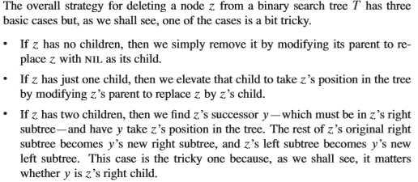
Case 1: If Z has no left child, then we replace Z by its right child, which may or may not be NIL. Case 1 applies to the scenario of Z having ONLY A RIGHT CHILD OR NOT HAVING ANY CHILDREN.
*When the right child is also NIL, this case accommodates the scenario where Z has no left or right child. In other words, Z has no children.
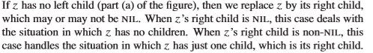
Case 2: If Z has no right child, but does have a left child, then we replace Z by its left child.
*Case 3 has a Case 3A and a Case 3B.
Case 3: Z has both a left and right child. We find Z’s successor, y, which lies in Z’s right subtree and has no left child. We want to splice y out of its current location and have it replace Z in the tree.
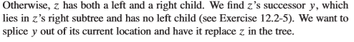
It’s true that because if it had a left child, then the left child would be the successor.
Case 3A: If y (the successor) is Z’s right child, then we replace Z by y, leaving y’s right child alone.
Case 3B: Otherwise, y lies within Z’s right subtree, but is not Z’s right child. In this case, we first replace y by its own child, and then replace Z by y.
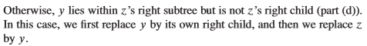

Transplant
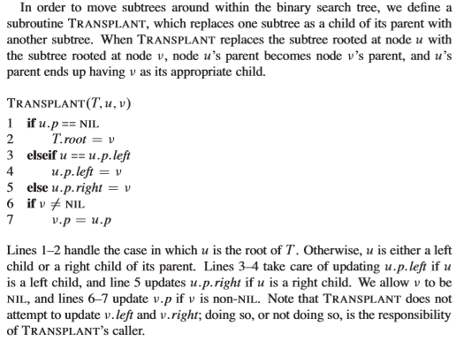

Tree Delete
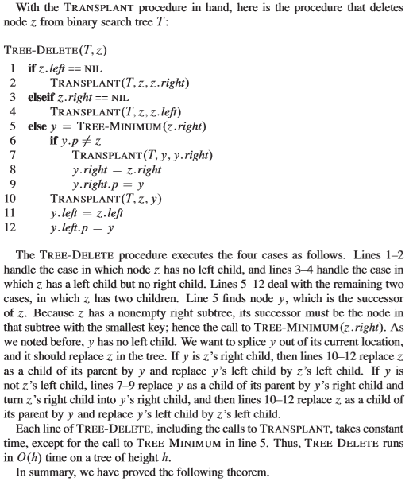

Tree Traversals
In Order Tree Walk
*Concept: You are traversing a tree in order from basically the left child to the root and then to the right.
In Order Tree Walk (Left, Root, Right) / In Order Tree Traversal: You traverse the left child, the root and then the right child.
*NOTE: In Order Tree Walk/traversal can apply to trees that are NOT Binary Search Trees. It doesn’t necessary ONLY apply for Binary Search Trees.
*If you were to utilize an in order tree traversal for a non binary search tree, the results may be not be in order.
You are recursively going through the left hand side of the root as well as the right hand side. You will recurse back up.
In Order Tree Walk prints in the middle.
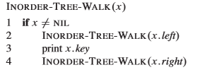* Easier to eyeball. Scarier to write out by hand at first.
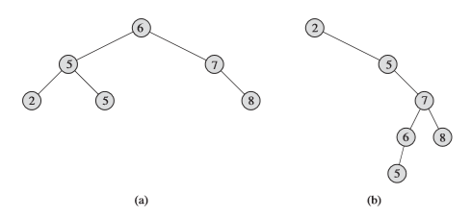
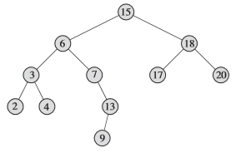Figure 12.2
InOrderTreeWalk of Sample A: 2, 5, 5, 6, 7, 8
InOrderTreeWalk of Sample B: 2, 5, 5, 6, 7, 8
InOrderTreeWalk of Figure 12.2: 2, 3, 4, 6, 7, 9, 13, 15, 17, 18, 20
Another way to memorize In Order Tree Walk: left, print, right
Pre Order Tree Walk (Root, Left, Right)/ Pre Order Tree Traversal: You traverse the root first, then the left child, and then the right child.
Pre Order Tree Walk prints first.
PREORDER-TREE-WALK(x):
if x != NIL:
print x.key
PREORDER-TREE-WALK(x.left)
PREORDER-TREE-WALK(x.right) * Easier to eyeball. Scarier to write out by hand at first.
Figure 12.2
PreOrderTreeWalk of Sample A: 6, 5, 2, 5, 7, 8
PreOrderTreeWalk of Sample B: 2, 5, 7, 6, 5, 8
PreOrderTreeWalk of Figure 12.2: 15, 6, 3, 2, 4, 7, 13, 9, 18, 17, 20
Another way to memorize Pre Order Tree Walk: print, left, right

Post Order Tree Walk (Left, Right, Root)/ Post Order Tree Traversal: You traverse the left child, then the right child, and then the root.
Post Order Tree Walk prints last.
POST-ORDER-TREE-WALK(x):
if x != NIL:
POST-ORDER-TREE-WALK(x.left)
POST-ORDER-TREE-WALK(x.right)
print x.key * Easier to eyeball. Scarier to write out by hand at first.

Figure 12.2

PostOrderTreeWalk of Sample A: 2, 5, 5, 8, 7, 6
PostOrderTreeWalk of Sample B: 5, 6, 8, 7, 5, 2
PostOrderTreeWalk of Figure 12.2: 2, 4, 3, 9, 13, 7, 6, 17, 20, 18, 15
Another way to memorize Post Order Tree Walk: left, right, print
*Caveat: InOrder, PreOrder, and PostOrder is not just for Binary Search Trees! Can be visualized for any tree/ any binary tree.
* Parameter is the pointer of the root of the tree (APPLIES FOR INORDER, PREORDER, and POSTORDER)

Chapter 15 – Dynamic Programming
Section 15.1 – Rod Cutting
*Definition of Dynamic Programming: A more optimal approach to divide and conquer.
Chapter 15 Overview:
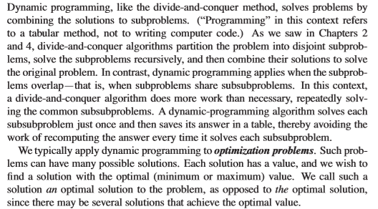
*Recap of Divide and Conquer: You divide a problems into subproblems, you conquer them (solve the subproblems), and there’s a merge step where you merge the subproblem, the solutions to the subproblem, and a larger (main solution) of the original problem.
Dynamic Programming is similar to divide and conquer; however, the biggest difference between Dynamic Programming and Divide and Conquer is that instead of recursively solving each individual subproblem, you can save the results of the individual subproblems and that saved result that results that you save can be utilized for future subproblems, so those future subproblems do not need to start from scratch in processing. If a particular smaller subproblem or piece of subproblem rather has already been solved, you do not need to attempt to solve it again. Thus, you already stored that solution and you can reference that solution.
*Steps to Dynamic Programming
1. Characterize the structure of an optimal solution.
2. Recursively define the value of an optimal solution (where you save that solution).
3. Compute the value of an optimal solution, typically in a bottom-up fashion (reference that solution).
4. Construct an optimal solution from computed information.
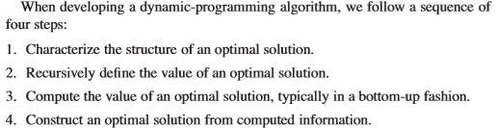
Also have a top-down solution/approach.

Textbook’s 1st Example of Dynamic Programming: The Rod Cutting Problem.
Overview of The Rod Cutting Problem: Given a rod of length of n inches and the table of prices
p_{i} for i = 1 to all the way to n: you would need to determine the maximum revenue obtainable by cutting up the rod and selling the pieces.
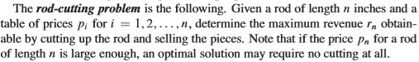
In other words, the best way to determine the most optimal solution can be defined as how do you cut that rod in such a way that it will MAXIMIZE the revenue given.
Rod Cutting Table:
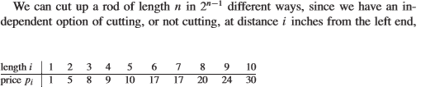
Example 1: let’s say that you want to find the maximum revenue to which the rod’s length is n = 5. The first thing that you need to do is to determine the number of possibilities which is determined by the formula: 2^{n-1.}. 2⁵⁻¹ = 2⁴ = 16 different ways to cut the rod when the length of the rod is n = 5.
1st Possibility: If we do not the cut the rod at all (leaving it at rod length [n = 5]), then the revenue would be $10.
2nd Possibility: If we cut the rod at 4 and 1 (splitting the rod with 4 and 1 [4 + 1 = 5]), the revenue would be $9 + $1 = $10.
3rd Possibility: If we cut the rod at 1 and 4 (splitting the rod with 1 and 4 [1 + 4 = 5]), the revenue would be $1 + $9 = $10.
4th Possibility: If we cut the rod at 3 and 2 (splitting the rod with 3 and 2 [4 + 1 = 5]), the revenue would be $8 + $5 = $13.
5th Possibility: If we cut the rod at 2 and 3 (splitting the rod with 2 and 3 [1 + 4 = 5]), the revenue would be $5 + $8 = $13.
6th Possibility: If we cut the rod at 3 and 1 and 1 (splitting the rod with 3 and 1 and 1 [3 + 1 + 1 = 5]), the revenue would be $8 + $1 + $1 = $10.
7th Possibility: If we cut the rod at 1 and 1 and 3 (splitting the rod with 1 and 1 and 3 [1 + 1 + 3 = 5]), the revenue would be $1 + $1 + $8 = $10.
9th Possibility: If we cut the rod at 1 and 3 and 1 (splitting the rod with 1 and 3 and 1 [1 + 3 + 1 = 5]), the revenue would be $1 + $8 + $1 = $10.
10th Possibility: If we cut the rod at 2 and 2 and 1 (splitting the rod with 2 and 2 and 1 [2 + 2 + 1 = 5]), the revenue would be $5 + $5 + $1 = $11.
11th Possibility: If we cut the rod at 2 and 1 and 2 (splitting the rod with 2 and 1 and 2 [2 + 1 + 2 = 5]), the revenue would be $5 + $1 + $5 = $11.
12th Possibility: If we cut the rod at 1 and 1 and 1 and 1 and 1(splitting the rod with 1 and 1 and 1 and 1 and 1 [1 + 1 + 1 + 1 + 1 = 5]), the revenue would be $1 + $1 + $1 + $1 + $1 = $5.
13th Possibility: If we cut the rod at 1 and 1 and 1 and 1 and 1(splitting the rod with 1 and 1 and 1 and 1 and 1 [1 + 1 + 1 + 1 + 1 = 5]), the revenue would be $1 + $1 + $1 + $1 + $1 = $5.
14th Possibility: If we cut the rod at 1 and 1 and 1 and 1 and 1(splitting the rod with 1 and 1 and 1 and 1 and 1 [1 + 1 + 1 + 1 + 1 = 5]), the revenue would be $1 + $1 + $1 + $1 + $1 = $5.
15th Possibility: If we cut the rod at 1 and 1 and 1 and 1 and 1(splitting the rod with 1 and 1 and 1 and 1 and 1 [1 + 1 + 1 + 1 + 1 = 5]), the revenue would be $1 + $1 + $1 + $1 + $1 = $5.
16th Possibility: If we cut the rod at 1 and 1 and 1 and 1 and 1(splitting the rod with 1 and 1 and 1 and 1 and 1 [1 + 1 + 1 + 1 + 1 = 5]), the revenue would be $1 + $1 + $1 + $1 + $1 = $5.
Based on all 16 possible ways to cut the rod when n = 5, the 4th and 5th possibility showed the maximum revenue, which is $13. Which is made from 3 + 2 or 2 + 3.
Example 2: let’s say that you want to find the maximum revenue to which the rod’s length is n = 4. The first thing that you need to do is to determine the number of possibilities which is determined by the formula: 2^{n-1.}. 2⁴⁻¹ = 2³ = 8 different ways to cut the rod when the length of the rod is n = 4.
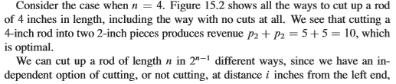
Example 2: Possibilities of cutting the rod when length of 4
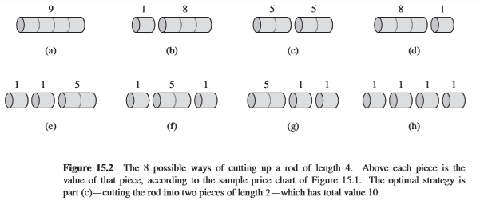
There are 2^{n-1} ways to come up scenarios for The Rod Cutting Problem.
The Rod cuts into k pieces for some 1 <= k <= n
Optimal Decomposition: n = i₁ + i₂ + … + i_{k} which corresponds to
The Maximum Corresponding Revenue: r_{n} = p_{i1} + p_{i2} + .. + p_{ik}
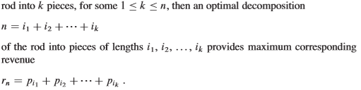
Max Revenue Table:
Revenue Rod Cuts
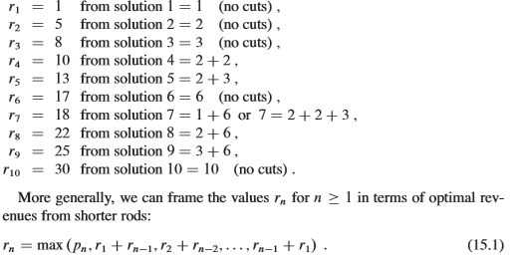Max Revenue Equation
Enhanced Max Revenue Equation:
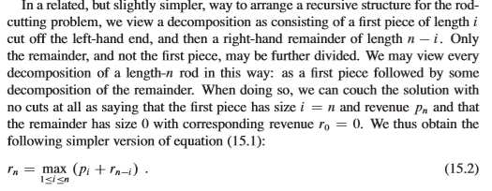
Rod Cutting Recursive Top-Down Implementation:
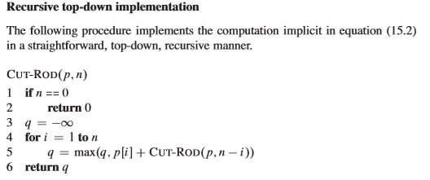
*p is the array that contains the prices (prices stored in the array).
Breakdown of Recursive Top - Down Rod Cutting: This will actually go through each and every scenario. The number of scenarios is found by 2^{n-1}, constantly recomputing because it’s a divide and conquer and keeps constantly recomputing and then ultimately obtaining the maximum revenue from the algorithm; however, the problem with that it it’s ineffieicent and if you program is going to run when N = A large number, then it’s not good.
*One example of a bad scenario is when N = 40. The program will take at least several minutes, and most likely more than an hour and every time that you increase N by 1, then your runtime of your program will DOUBLE (exponential).
There is a more optimal approach to the Recursive Rod Cutting Problem.
Figure 15.3 Recursion Tree:
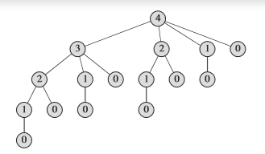
This tree reflects when the rod length is 4 (n = 4). Here, in this tree, it shows the possible ways that this rod can be cut. Based on this picture, you can cut it into 3 and 1, 2 and 2, 1 and 1 and 1 and 1, 2 and 1 and 1, and 0 (note that the 0 represents that the rod was not cut at all).
Ex 1: If you cut the rod into 3, then it would be 3 and 1 b/c 3 + 1 = 4.
Ex 2: If you cut the rod into 2, then it would be 2 and 2 b/c 2 + 2 = 4.
Ex 3: If you do not the cut the rod (0), then it would be 4 and 0 b/c 4 + 0 = 4.
Ex 4: If you took the route to cut it 3 and 1, so going to the 3 route, then you go to 2 and 1, so 2 + 1 = 3, OR go 1, so 1 + 1 + 1 = 3.
*However, we noticed a duplicate of 2 here, even though we went through the calculation of a 2. We noticed a duplicate of 1 here, even though we went through the calculation of a 1.
*We are reprocessing this whereas you may already have the solution from this branch here, why do you need to process this again when you have the solution here! Thus, the concept of Dynamic Programming comes in!
Memorization:
*Once you have a solution, you do what’s called a “Memoize”.
Memoize: Storing the solution of a dynamic programming problem to a data structure, such as an array.
With memoization, the algorithm “remembers” what results it has computed previously.
Essentially, using dynamic programming, you can go or implement a top-down with memoization or bottom-up method.

Two Ways to Approach Solving the Rod Cutting Problem via Dynamic Programming:
- Top - Down With Memoization: Write the procedure in a manner as if its recursive, but modify it to save the result of each subproblem (usually into an array or a hashtable).

Essentially, the procedure checks to see whether it was previously solved, whether the subproblem was previously solved, and if has returns the same value. Basically, saving further computation at that level and if not, the procedure computes the value in the usual manner.

The procedure first checks to see whether the subproblem was already solved. If so, it returns the saved value, saving further computation at that level. If it wasn’t already solved, then the procedure computes the value in the usual manner.

- Bottom – Up Approach: This method depends on some size of a subproblem such that solving any particular subproblem depends on solving on only solving the smaller subproblem, so then we sort the subproblem by size and solve them in size order smallest first because naturally as you go bottom-up. There’s a DEPENDENCY on the previously solved problems, so when we solving a particular subproblem, we have already solved all of the smaller subproblems, it’s solution depends on and we saved there’s because we have saved their solutions, so we solve each subproblem only once when we see it.

A particular subproblem depends on smaller subproblems. We sort the subproblems by size and solve them in size order, smallest first. When solving a particular subproblem, we have already solved all of the smaller subproblems it’s solutions depends upon, and we have saved their solutions, so we solve each subproblem only once.

Memoized Cut Rod Algorithm Top – Down:
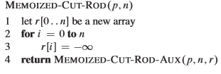 AKA MCR
Top-Down implementation of the rod cutting problem.
*r[0 .. n] is a new array which is called an “Auxiliary Array” and the revenue is stored in the array (revenue of rod cutting).
*for i = 0 to n: ; you first set r[i] (initialize revenue array to negative infinity for each value).
Calls Memoized Cut Rod Aux.

Memoized Cut Rod Aux Bottom Up Approach:
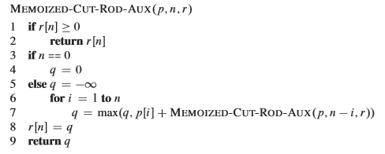 AKA MCRA
Can be modified to provide the optimal cutting.
*r is the array of max revenues per rod length.
*p is the array of prices per rod length.
*n is the rod of the length.
*The line q = max(q, p[i] + MEMOIZED-CUT-ROD-AUX(p, n – i, r)) takes the maximum value of the revenues calculated so far and storing that into r[n].
* Memoized Cut Rod Aux (MCRA) ONLY returns the maximum revenue, NOT returning individual cuts of the rod (returning optimal revenue, but NOT optimal cutting).
*Brief Summary of Memoized Cut Rod Aux (MCRA): It’s comparing the various cuts of the rod and then it’s actually storing that maximum value of the revenue of the array (line 8: r[n] = q).
*Concept of Memoized Cut Rod Aux (MCRA): It is going top-down and in each step of the way, it’s saving the values.
Properties of MCR and MCRA:
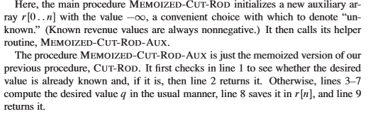
*Runtime of Memoized Cut Rod (MCR – Top Down) is O(n²).

Figure 15.4 Top Down
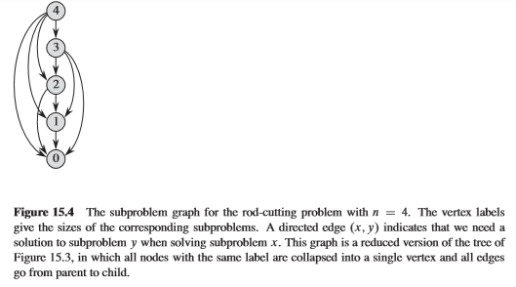
When n = 4, it refers to when the length of the rod is 4.
In figure 15.4, as it goes top-down, it’s actually saving the values and it could actually reference the values as it goes through.
Bottom Up Cut Rod Algorithm:

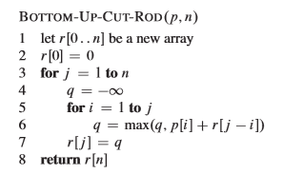
*p is the price list (array of prices per rod length).
*n is the length of the rod.
A simpler version of Top-Down approach of Memoized Cut Rod(MCR).
*Bottom Up Cut Rod is going from 1 to n, so it’s starting with a cut size of 1 and it is working its way up.
*r is the array storing the maximum revenue for each cut.
*for i = 1 to j: This is where you actually do the calculation and you can actually reference p[i] and r[i – j]. Can make reference from there and take the max instead of constantly recalculating every cut every step of the way.

Properties of Bottom Up Cut Rod:
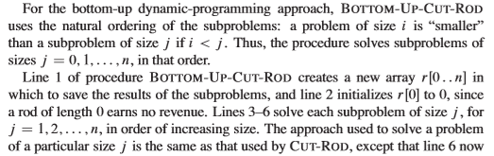
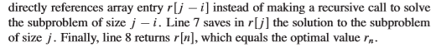
Runtime of Bottom Up Cut Rod: O(n²).
Memoized Cut Rod(Top-Down) vs. Bottom Up Cut Rod
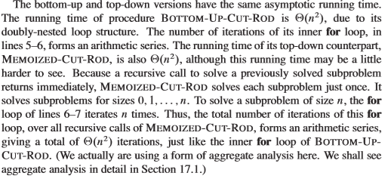
*Both Meomized Cut Rod (Top-Down) and Bottom Up Cut Rod has a runtime of O(n²).
*Reason why Memoized Cut Rod (Top-Down) is O(n²) is because of a recursive call to solve a previously subproblem immediately, the line q = max(q, p[i] + MEMOIZED-CUT-ROD-AUX(p, n – i, r)) is recursive the way that Memoized Cut Rod solves each subproblem is for size 0, 1, … n. To solve subproblem for size n, the for loop of lines 6 and 7 of MCR iterate n times. Thus, by looping over all of the recursive calls (q = max(q, p[i] + MEMOIZED-CUT-ROD-AUX(p, n – i, r))) of MCR forms an arithmetic series giving a total of O(n²) iterations. (hard to see)
*Reason why Bottom Up Cut Rod is O(n²) is because of the inner for loop (doubly – nested loop) structure. The total number of iterations of its inner for loop from lines 5 – 6 forms an arithmetic series, thus giving the runtime of O(n²).

Figure 15.3 Revisit:
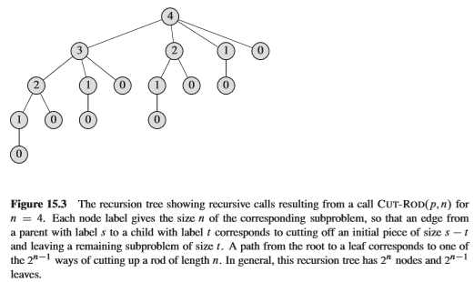
Once again, this figure is represented as a recursion tree when the length of the rod is 4 (n = 4).
Ex 1) Top-Down: It starts at 4, so it goes as 4, 3, 2, 1. Then 3 goes to 2, but it NOTICES 2 has been already been calculated, thus it does not recalculate 2 all over again. So this 2 references that 2. This 1 references that 1. This 0 references that 0.
Ex 2) Bottom-Up: We start with 0 (the one on the very bottom). We calculate 0. 1 depends on 0. So, 0 has been calculated. We do some minor computations on 1, we get the value. 2 depends on 1 and 0, so we already calculated 0, so obtain that 0 and the 1. Here, it references the 1 and 0 and it has the value for 2. 3 references 2, 1, and 0, so the 1 has already been calculated, 2 has already been calculated, 0 has already been calculated. 3’s computation is made through 2, 1, and 0.
*Recap of Dynamic Programming: The key takeaway of Dynamic Programming is that you save your solutions to a data structure. You save the solution as you go through the recursive calls/algorithm. In general, you save the solutions to an array or a hashtable and it can referenced from there, instead of constantly doing the recalculation.
We see that in Figure 15.4 mentioned above.
*NOTE: In both the Memoized Top Down and Bottom Up Cut Rod, these will ONLY give (return) you the maximum revenue.
Here’s an algorithm that will give you both the maximum revenue as well as the optimized cutting which is Extended Bottom Up Cut Rod (Slightly version of Bottom Up Cut Rod).

Extended Bottom Up Cut Rod Overview:
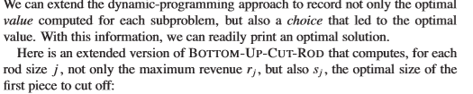
Extended Bottom Up Cut Rod:
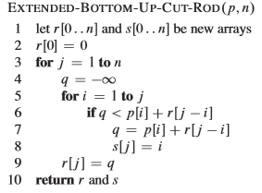
*Returns both, the maximum revenue and the individual cuts of the rod, so array s will indicate which values of the cuts or length of the cuts involved. It gives what the curs are.
However, this algorithm isn’t enough when you want to print what the cuts are, so we need to utilize the Print Cut Rod Solution takes care of it.
Print Cut Rod Solution:
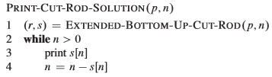
Print Cut Rod Solution Price Table:
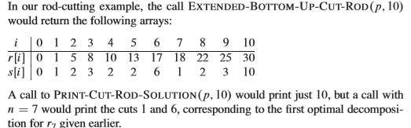
*Prints out the various cuts that provide an optimal revenue.
*Prints what those cuts are.
*Associates with Extended Bottom Cut Up Rod.

Dynamic Programming Example Top Down Approach Overview:
Ex 1: Let n = 4, meaning that the length of the rod is 4.
We find that the number of scenarios is 2^{n-1} = 2⁴⁻¹ = 2³ = 8 scenarios. We need to determine the max revenue that would obtain by cutting the rod based on the prices within the range from 1 to the range of n (n is included).
p = <1, 5, 8, 9>
Memoized Cut Rod (MCR)
Memoized Cut Rod Aux = (MCRA)
MCR (p, n = 4):
r = <null, null, null, null, null>
for i = 0 to n = 4:
r[i] = -infinity
//so all the elements of r become negative infinity
// Initialization r = <-infinity, -infinity, -infinity, -infinity, -infinity>
return MCRA (p, n = 4, r)
// r is the array of revenues.
MCRA (p, n = 4, r): 1st time
if r[n] = r[4] = -infinity >= 0: NO
if n = 4 == 0: NO
else:
q = -infinity
i = 1: for i = 1 to n = 4:
q = max(q = -infinity, p[i] = p[1] = 1 + MCRA (p, n = 4 – i = 1 = 3, r)) //IMMEDIATELY RECURSE DURING MCRA before going to the next iteration
q = max(-infinity, 1 + MCRA (p, 3, r)) = max(-infinity, 1 + 8) = max(-infinity, 9) = 9
i = 2: for i = 2 to n = 4: // Here, you carry on the q value from 1st iteration to n^{th} iteration
q = max(q = 9, p[i] = p[2] = 5 + MCRA (p, n = 4 – i = 2 = 2, r))
q = max(9, 5 + MCRA (p, 2, r)) = max(9, 5 + 5) = max(9, 10) = 10
i = 3: for i = 3 to n = 4:
q = max(q = 10, p[i] = p[3] = 8 + MCRA (p, n = 4 – i = 3 = 1, r))
q = max(10, 8 + MCRA (p, 1, r)) = max(10, 8 + 1) = max(10, 9) = 10
i = 4: for i = 4 to n = 4:
q = max(q = 10, p[i] = p[4] = 9 + MCRA (p, n = 4 – i = 4 = 0, r))
q = max(10, 9 + MCRA (p, 0, r)) = max(10, 9 + 0) = max(10, 9) = 10
r[n] = r[4] = q = 10
return q = 10
// Update 5 on r: r = <0, 1, 5, 8, 10>
*MCRA (p, n = 4, r) = 10
MCRA (p, n = 3, r): 1st time
if r[n] = r[3] = -infinity >= 0: NO
if n = 3 == 0: NO
else:
q = -infinity
i = 1: for i = 1 to n = 3:
q = max(q = -infinity, p[i] = p[1] = 1 + MCRA (p, n = 3 – i = 1 = 2, r))
q = max(-infinity, 1 + MCRA(p, 2, r)) = max(-infinity, 1 + 5) = max(-infinity, 1 + 5) = max (-infinity, 6) = 6
i = 2: for i = 2 to 3: // Here, you carry on the q value from 1st iteration to n^{th} iteration
q = max(q = 6, p[i] = p[2] = 5 + MCRA (p, n = 3 – i = 2 = 1, r))
q = max(6, 5 + MCRA (p, 1, r)) = max(6, 5 + 1) = max(6, 6) = 6
i = 3: for i = 3 to 3:
q = max(q = 6, p[i] = p[3] = 8 + MCRA (p, n = 3 – i = 3 = 0), r))
q = max(6, 8 + MCRA(p, 0, r)) = max(6, 8 + 0) = max(6, 8) = 8
r[n] = r[3] = q = 8
return q = 8
// Update 4 on r: r = <0, 1, 5, 8, -infinity>
*MCRA (p, n = 3, r) = 8

MCRA (p, n = 2, r): 1st time
if r[n] = r[2] = -infinity >= 0: NO
if n = 2 == 0: NO
else:
q = -infinity
i = 1: for i = 1 to n = 2:
q = max(q = -infinity, p[i] = p[1] = 1 + MCRA (p, n = 2 – i = 1 = 1, r))
q = max(-infinity, 1 + MCRA (p, 1, r)) = max(-infinity, 1) = 1
i = 2: for i = 2 to n = 2: // Here, you carry on the q value from 1st iteration to n^{th} iteration
q = max(q = 1, p[i] = p[2] = 5 + MCRA (p, n = 2 – i = 2 = 0, r))
q = max(1, 5 + MCRA(p, 0, r)) = max(1, 5 + 0) = max(1, 5) = 5
r[n] = r[2] = q = 5
return q = 5
// Update 3 on r: r = <0, 1, 5, -infinity, -infinity>
*MCRA (p, n = 2, r) = 5
MCRA (p, n = 1, r): 1st time
if r[n] = r[1] = -infinity >= 0: NO
if n = 1 == 0: NO
else:
q = -infinity
i = 1: for i = 1 to n = 1:
q = max(q = -infinity, p[i] = p[1] = 1 + MCRA (p, n = 1 – i = 1 = 0, r)) // leads to base case
q = max(-infinity, 1 + MCRA (p, 0, r)) = max(-infinity, 1 + 0) = max(-infinity, 1) = 1
r[n] = r[1] = q = 1
return q = 1
// Update 2 on r: r = <0, 1, -infinity, -infinity, -infinity>
*MCRA (p, n = 1, r) = 1

MCRA (p, n = 0, r): 1st time
if r[n] = r[0] = -infinity >= 0: NO
if n = 0 == 0: YES
q = 0
else: NO
r[n] = r[0] = q = 0
return q = 0
// Update 1 on r: r = <0, -infinity, -infinity, -infinity, -infinity>
*MCRA (p, n = 0, r) = 0
MCRA (p, n = 3, r): After 1st time
if r[n] = r[3] = 8 >= 0:
return r[n] = r[3] = 8 // DYNAMIC PROGRAMMING BENEFIT
MCRA (p, n = 2, r): After 1st time
if r[n] = r[2] = 5 >= 0: YES
return r[n] = r[2] = 5 // DYNAMIC PROGRAMMING BENEFIT
MCRA (p, n = 1, r): After 1st time
if r[n] = r[1] = 1 >= 0: YES
return r[n] = r[1] = 1 // DYNAMIC PROGRAMMING BENEFIT
MCRA (p, n = 0, r): After 1st time
if r[n] = r[0] = 0 >= 0: YES
return r[n] = r[0] = 0 // DYNAMIC PROGRAMMING BENEFIT

*FINAL UPDATED r: r = <0, 1, 5, 8, 10>
MCR(p, n = 4) returns MCRA(p, n = 4, r). The result of MCRA(p, n = 4, r) is 10, thus the value of MCR(p, n = 4) is 10 hence the maximum revenue obtained by cutting the rod of length is 4.
*CAVEAT: The r array (maximum revenue array) starts at index 0!
r represents the maximum revenue at every step of the way.
*Why does r start at 0: 0 is the base case. Also, 0 indicates where no cuts are made (left as is). 0 represents 0 cuts.
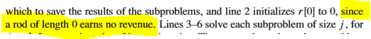regards bottom – up, but similar concept
*Revenue Array starts at index 0 because of the base case of not cutting the rod at all (TRICKY).
*MCRA does not execute the entire algorithm, every time, so it save processing power.By breaking out of the algorithm right after it returns the saved solution (subproblem), it saves processing power.
*Best Case of MCRA: It references the stored solution of a subproblem and it immediately returns the value which its runtime is O(1).
*Non-Dynamic Rod Cutting: O(2^{n}) – exponential: terrible!
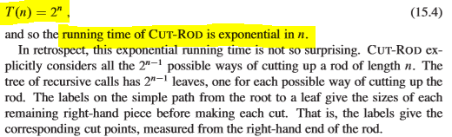

Chapter 16 – Greedy Algorithms
Section 16.1 – An Activity Selection Problem
*Definition of Greedy Algorithms: Always makes the best choice that looks best at the moment.
Unlike Dynamic Programming, Recursive Algorithms, and Iterative Algorithms, those look over all the possible solutions, yet the Greedy Algorithm always makes the best choice that looks best at the moment.
*Greedy Algorithms do not look at all the possible solutions and then later choosing the best out of all of them.
*Aims to make a locally optimal choice, in hopes that this choice will lead to a globally optimal solution.
*Greedy Approach Steps (Step by Step Approach):
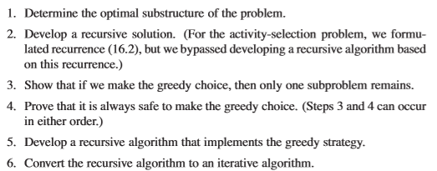
*Difference between Step 2 and Step 5: Step 2 is not necessarily a greedy solution, basically a recursive solution; however, Step 5 turns that recursive solution to a greedy approach.
*Definition of Optimal Substructure: Indicating that the best choice at that particular moment will lead to the overall optimal choice.
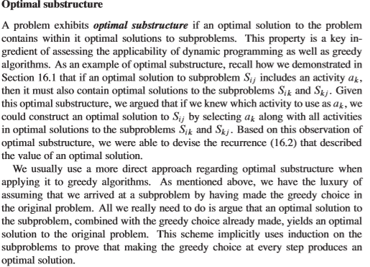

Examples of Optimal Substructure: Activity Selector Problem, 0-1 Knapsack, Fractional Knapsack.
Activity Selection Problem:
*Overview:
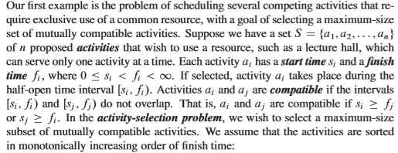
Let’s say that you have a lecture hall and you want to assign elements to that, so your goal is to have as many as events at that lecture hall as possible; thus maximizing your revenue.
In Other words, you want to try to have has much as events at that lecture hall; however, the problem is that the events that you want to reserve the lecture hall has different start and end times associated to them.
In Other words, you cannot allocate two events with overlapping times!
Activity Selection Problem Overview:
*We wish to select a maximum – size subset of mutually compatible activities.
*We assume that the activities are sorted in monotonically increasing order of finish times.
Book’s Activity Time Table:
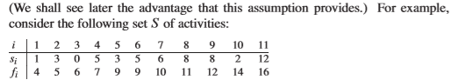
Events are the same things when someone says Activities.
*NOTE: You can only assign a certain number of activities to the lecture hall.
*i is the activity number.
*S_{i} is the starting time of that activity.
*f_{i} is the finishing time of that activity.
*Activities are sorted by increasing order of finishing time.
*We wish to select a max – size subset of mutually compatible activities means to have as the most highest number of activities that you can assign, having it in a subset.

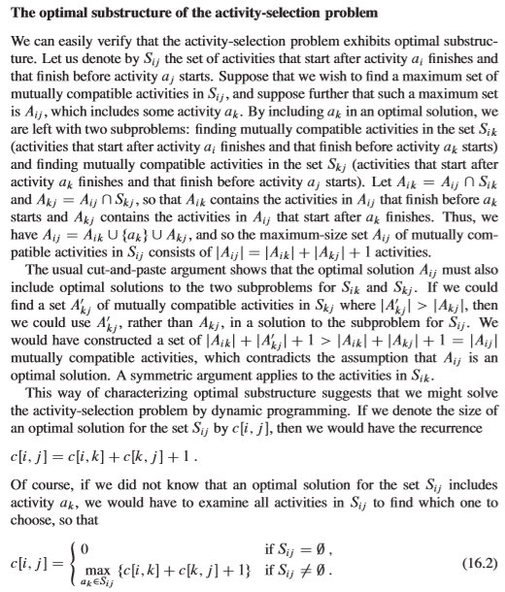
*Ex 1: Finding the max subset using the greedy choice:
Step 1: Always choose the first activity. The first activity is a₁.
We add activity a₁ to the subset.
1st Update of subset: { a₁}
*Activity a₁ has a start time of 1 and a finishing time of 4.
*The way that we select the next activity is to have the starting time of the next activity to be greater than or equal to the current’s activity finishing time.
In this case, the next activity must have a starting time of 4 or greater.
Step 2: Because we determined the finishing time of activity a₁ which was 4, we need to find an activity that has a starting time greater than or equal to 4.
Activity a₂ starting time is 3. Is 3 >= 4, NO.
Activity a₃ starting time is 0. Is 0 >= 4, NO.
Activity a₄ starting time is 5. Is 5 >= 4, YES.
We add activity a₄ to the subset.
2nd Update of subset: {a₁, a₄}
*Activity a₄ has a start time of 5 and a finishing time of 7.
*NOTE, we do not choose activity a₆ even though the starting time as activity a₄ because we its sorted in monotonically increasing order of finish time.
Step 3: Because we determined the finishing time of activity a₄ which was 7, we need to find an activity that has a staring time greater than or equal to 7.
Activity a₅ starting time is 3. Is 3 >= 7, NO.
Activity a₆ starting time is 5. Is 5 >= 7, NO.
Activity a₇ starting time is 6. Is 6 >= 4, NO.
Activity a₈ starting time is 8. Is 8 >= 7, YES
We add activity a₈ to the subset.
3rd Update of subset: { a₁, a_{4,} a₈}
*Activity a₈ has a start time of 8 and a finishing time of 11.
*NOTE, we do not choose activity a₈ even though the starting time as activity a₈ because we its sorted in monotonically increasing order of finish time.

Step 4: Because we determined the finishing time of activity a₈, which was 11, we need to find an activity that has a starting time greater than or equal to 11.
Activity a₉ has a starting time of 8. Is 8 >= 11, NO.
Activity a₁₀ has a starting time of 2. Is 2 >= 11, NO.
Activity a₁₁ has a starting time of 12. Is 12 >= 11, YES.
We add activity a₁₁ to the subset.
4th Update of subset: {a₁, a₄, a₈, a₁₁}
Final Subset using the Greedy Approach: {a₁, a₄, a₈, a₁₁}.
*NOTE: After you sort into monotonically, increasing order of finish time, the first activity will always be a part of your max subset. It will always be a part of your max subset, assuming that the finish times are in monotonically increasing order.
The solution from the greedy algorithm will provide you one solution; however, there could be other solutions.
Taking another approach will possibly lead you to a different solution. In other words, the output of the greedy algorithm does not provide the only solution available.
There can be other max activity selection subsets. There could be other maximum size subsets of this of this start finish time ordering.

*Ex 2: Another max subset without the Greedy Approach.
Max Subset = {a₂, a₄, a₉, a₁₁} // this was found due to eradicating as many gaps as possible.
Q. This example does not contain activity a₁ (1st activity). Does this contradict what I said earlier?
A. No, what I meant to say earlier was that the very first activity be in a max subset, but there could be different types of max subsets. The subset {a₂, a₄, a₉, a₁₁} happens to be another subset to not have the first activity, but the first activity will always be A max subset!
There is both an iterative as well as a recursive solution.
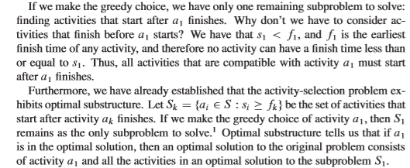
Recursive Activity Selector Problem Algorithm:
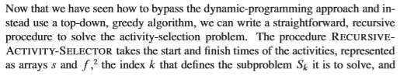
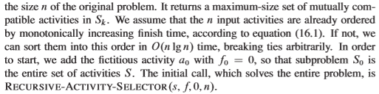
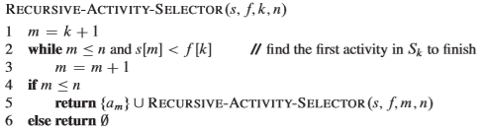

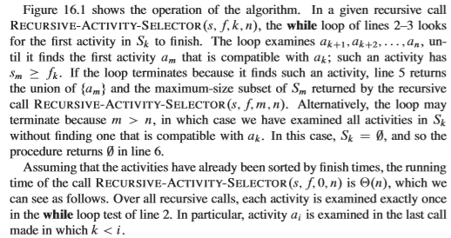
Recursive Activity Selector Algorithm: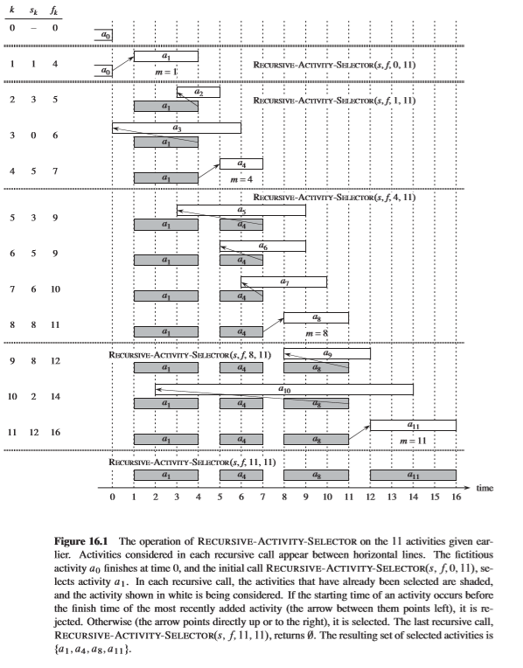
Greedy Activity Selector Problem Algorithm:
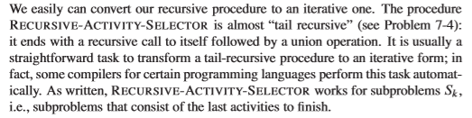
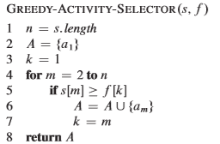

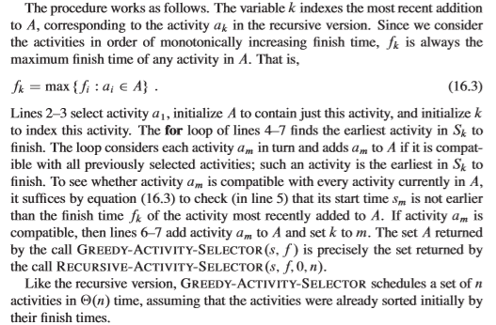
*Both recursive activity selector and greedy activity selector returns the same result, but the greedy activity selector is easier to visualize what’s happening.
*Recap: The first activity will always be in a max subset.
The Greedy Activity Selector Algorithm assumes that you already ordered the activities by monotonically increasing finish time, assumes that the input are ordered by finish monotonically increasing finish time.
*By looking at the Greedy Activity Selector, every time every iteration, (Line 4) you are determining the optimal substructure by checking to find the next activity start time that’s greater than or equal to the current activities finish time (Line 5). Then you are appending that to the max subset (adding to the max subset – Line 6). You’re moving on m, basically moving on that last activity (Line 7), so you are doing that comparison again in the next iteration until no more activities can be scheduled.
*Recap: After choosing the 1st activity to add into the subset, we then select the next activity based on the starting time that is greater than or equal to the current activity’s finish time.
*NOTE: If two activities have the same starting time (2 or more) but have different finishing times, you must choose the one that ends the quickest (go to closes one to current activity).
If we observe that 2 or more activities have the same starting time and same finishing times, you are free to chose any one. A big gap for scheduling events is a PROBLEM because the greedy algorithm is not able to schedule anything else if the event that takes all day is actually appended to the subset, thus not resulting in a max subset.

Section 16.2 – Elements of the Greedy Strategy
Types of Knapsack Problems: 0-1 Knapsack and Fractional Knapsack.
*Knapsack Problem Overview:
A thief robs a store and find n items and so the ith item is worth v_{i} dollars and weighs w_{i} pounds. Assume v_{i} and w_{i} are integers. The thief wants to take as a valuable as a load as possible, but he can carry at most W pounds in his knapsack.
Q. Which items should he take?
*0 – 1 Knapsack:
-Cannot use Greedy Algorithm.
-You cannot break up items into fractions, must take the entire item
-By 0 – 1 characteristic, you must take the entire item as a whole or don’t take it (1 – take), (0 – leave it).
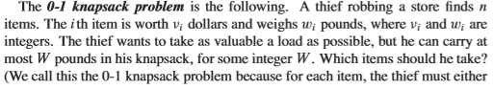
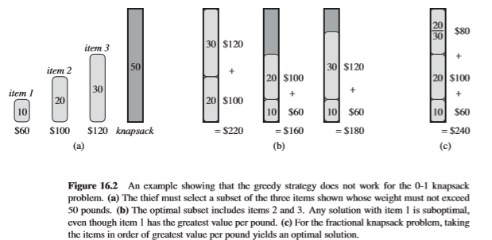
Figure 16.2 Setup
*The value/lb is determined by the cost of item divided by the weight of the item!
Item 1’s value/lb is $60 / 10lbs = $6/lb
Item 2’s value/lb is $100 / 20lbs = $5/lb
Item 3’s value/lb is $120 / 30lbs = $4/lb

Ex 1: 0 – 1 Knapsack
We know that the total capacity of the knapsack is 50. One possibility to take is that the thief takes the 30lb item as well as the 20lb item which fulfills the requirement within the constraint of having enough space in the knapsack. That approach will have the value of $120 + $100 = $220.
However, if you take a greedy approach start by going to the piece that has the highest value/lb. So, you take the 10 lb ($60) which results of the knapsack having 40 lbs left for its capacity. Then the thief takes the 20 lb ($100) which results of the knapsack having 20 lbs left for its capacity. By the time that the thief tries to take the 30 lb ($120) item, by the 0-1 Knapsack constraint whereas they cannot break up the 30lb piece, they have to either take it as a whole or leave it. B/c of the 0-1 knapsack, the thief isn’t able to steal the 30 piece and thus has to leave it behind. By using the greedy approach, the thief was able to grab the 10lb piece as well as the 20lb piece. Knowing that the total value worth that he stole was $60 + $100 = $160 and it was less than $220 (30 lb + 20 lb – Non Greedy Approach), thus a counterexample appears!
*NOTE: By trying different heuristics instead of value/pound. Let’s say if you want to just take the largest item and go from there, you can still find a counterexample where the Greedy Approach will not work for a 0 – 1 Knapsack Problem.
*Fractional Knapsack Overview: The setup is very similar to the 0 – 1 Knapsack; however, the thief can now take fractions of items rather than having to make a 0 – 1 choice (take it or leave it). The thief can actually, let’s say a thief has a grinder or a tool that can grind up the items to make it fit into the knapsack.
*Fractional Knapsack:
-Greedy algorithm does work.
-You can take fraction of items in order to fit them into the thief’s knapsack.
-You must sort the items in monotonically descending order of value/pound. In other words, from highest value/pound to lowest value/pound (Constraint: Before running Fractional Knapsack Problem).
Ex 2: Fractional Knapsack Problem
We know that the knapsack has a capacity of 50. We approach this by first sorting the price/lb in monotonically increasing order. We noticed that we placed the 10lb ($60) item first because the cost was the highest ($6/lb) followed by the 20lb ($100) item because it’s the second highest ($5/lb) followed by the 30lb ($120) because it was the least highest ($4/lb).
Then, we use the greedy approach to get as much value as possible, so we first take the 10lb ($60) item as a whole because the knapsack has enough space to take it as a whole. After taking the 10lb item, the knapsack has 50 – 10 = 40 left. Then, we take the 20lb ($100) as a whole because the knapsack still has enough space even though we took the 10lb item already. After taking the 20lb item, the knapsack has 40 – 20 = 20 left. Then, we take the 30lb ($120) as a whole, but we cannot take it as a whole because the knapsack has 20 left (inefficient space), but by fractional knapsack, the thief is able to take 20/30’s of the 30lb piece, this leaving the knapsack’s space to 0. Because the thief was only able to grab the remaining 2/3’s of the 30lb item, the cost is $\frac{20}{30} * \$120 =$ $80. Thus, the total value of the thief’s run was $60 + $100 + $80 = $240.
*The Way to get the cost of the remaining space of the last pieces: $\frac{Remaining knapsack space}{Weight of the entire item}$
*Fractional Knapsack Algorithm:
Fractional Knapsack(v, w, W) {
load = 0 //weight of the items stolen
i = 1 // iterator used to iterate
n = w.length // number of items available to steal
value = 0 // value of items stolen so far
while load < W and i <= n // while the weight of stolen items is less than W
{
if w_i <= W – load // checks to see if you can fit the entire item into your knapsack,
{
load = load + w_i // adds item to the weight of the knapsack
value = value + v_i // adds to the amount of values of the items in the knapsack
}
else // if the entire item can’t fit into the knapsack, then you need to take a fraction of the item
{
load = load + (W - load) / w_i // takes the remainder of what your knapsack can handle divided by w_i
value = value + v_i * (W – load) / w_i
} // at the end of the else condition, this load at the end should equal W b/c W is the max
i++ // increment iterator
}
return load, value
}
*Exception: If the amount of items, the weights of items is less than W (weight of total items).
*Fractional Knapsack is a Greedy Algorithm b/c if you sort the items by value/lb or value/weight in monotonically descending order, you are able to obtain the look at the optimal substructure of the problem in each iteration.

